**Ex. No.:1.1**

**Salary Calculation**

**PROGRAM**

import java.util.Scanner;

public class Wage{

public static void main (String[] args){

Scanner sc=new Scanner(System.in);

double a=sc.nextDouble(),d,e,s;

int b=sc.nextInt();

int c=sc.nextInt();

if (b>40){

e=b-40;

s=40*a*c;

d=1.5*a*e*c;

s=s+d;

System.out.print(s);

}

else if (b<20){

s=a*b*c;

e=s*(0.1);

s=s-e;

System.out.print(s);

}

else{

s=a*b*c;

System.out.print(s);

}

}}

**OUTPUT**

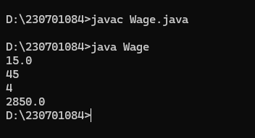

**Ex. No.:1.2**

**Bill Generation**

**PROGRAM**

**import java.util.*;**

**class Ticket{**

**public static void main(String args[]){**

**Scanner sc=new Scanner(System.in);**

**String t=sc.nextLine();**

**int n=sc.nextInt();**

**double price=0;**

**double dis=0;**

**if(t.equals("Regular")){**

**price=50;**

**if(n>10) dis=0.10;**

**}else if(t.equals("VIP")){**

**price=100;**

**if(n>5) dis=0.15;**

**}else if(t.equals("Premium")){**

**price=150;**

**if(n>3) dis=0.20;**

**}else{**

**System.out.println("Invalid input");**

**}**

**double cost=price*n;**

**cost-=cost*dis;**

**if(cost<200){**

**cost+=20;**

**}**

**System.out.println(cost);**

**}**

**}**

**OUTPUT**

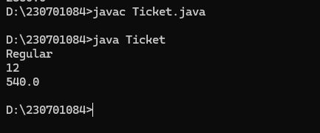

**Ex. No.:1.3**

**Largest and smallest digit of a number**

**PROGRAM**

**import java.util.*;**

**class Digit{**

**public static void main (String[] args){**

**Scanner sc = new Scanner(System.in);**

**int n=sc.nextInt();**

**int largest = 0;**

**int smallest =9;**

**while(n>0){**

**int a = n%10;**

**if(a>largest){**

**largest = a;**

**}**

**if (a<smallest){**

**smallest = a;**

**}**

**n=n/10;**

**}**

**System.out.println(largest +" " +smallest);**

**}**

**}**

**OUTPUT**

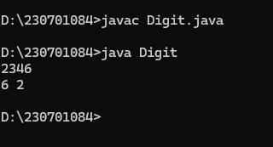

**Ex. No.:1.4**

**i) Zero-One Triangle Pattern**

**PROGRAM**

**import java.util.Scanner;**

**public class Triangle {**

**public static void main(String[] args) {**

**Scanner scanner = new Scanner(System.in);**

**System.out.print("Enter a positive integer: ");**

**int N = scanner.nextInt();**

**for (int i = 1; i <= N; i++) {**

**for (int j = 0; j < i; j++) {**

**System.out.print((i + j) % 2 + " ");**

**}**

**System.out.println();**

**}**

**scanner.close();**

**}**

**}**

**OUTPUT**

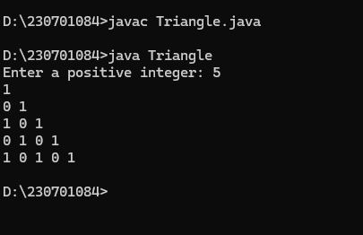

**ii) Number-increasing reverse Pyramid Pattern**

**PROGRAM**

**import java.util.Scanner;**

**public class Pyramid {**

**public static void main(String[] args) {**

**Scanner scanner = new Scanner(System.in);**

**System.out.print("Enter a positive integer: ");**

**int N = scanner.nextInt();**

**for (int i = 1; i <= N; i++) {**

**for (int j = 0; j < i; j++) {**

**System.out.print((i + j) % 2 + " ");**

**}**

**System.out.println();**

**}**

**scanner.close();**

**}**

**}**

**OUTPUT**

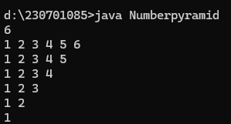

**Ex. No.:1.5**

**Identify theWeekday orWeekend**

**PROGRAM**

**import java.util.Scanner;**

**public class Dayofweek {**

**public static void main(String[] args) {**

**Scanner scanner = new Scanner(System.in);**

**String day = scanner.nextLine().trim();**

**switch (day) {**

**case "Monday":**

**case "Tuesday":**

**case "Wednesday":**

**case "Thursday":**

**case "Friday":**

**System.out.println("It's a weekday");**

**break;**

**case "Saturday":**

**case "Sunday":**

**System.out.println("It's a weekend");**

**break;**

**default:**

**System.out.println("Invalid day");**

**}**

**}**

**}**

**OUTPUT**

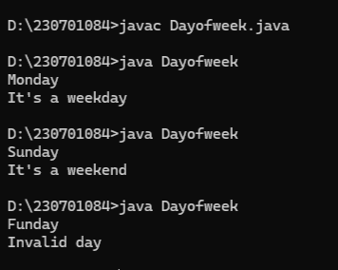

**Ex. No.:1.6**

**Strong Number**

**PROGRAM**

**import java.util.Scanner;**

**public class Strong{**

**public static void main(String[] args) {**

**Scanner scanner = new Scanner(System.in);**

**int num = scanner.nextInt();**

**scanner.close();**

**int sum = 0, temp = num;**

**while (temp > 0) {**

**int digit = temp % 10;**

**int fact = 1;**

**for (int i = 1; i <= digit; i++) fact *= i;**

**sum += fact;**

**temp /= 10;**

**}**

**System.out.println(sum == num ? "Strong number" : "Not a strong number");**

**}**

**}**

**OUTPUT**

